React Assignment

Q1: Create a simple body mass index as shown below.

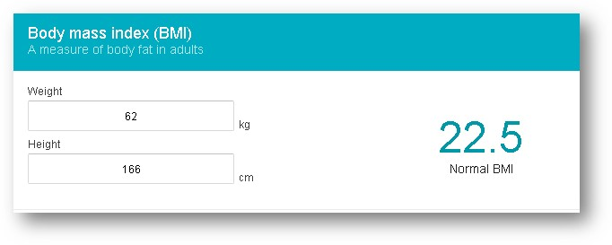

**BMI Categories:**

Underweight = <18.5

Normal weight = 18.5–24.9

Overweight = 25–29.9

Obesity = BMI of 30 or greater

**Formula**

cid:image002.png@01D41487.FC341840

Q2: Create a form to fill data and show the data in tabular form.

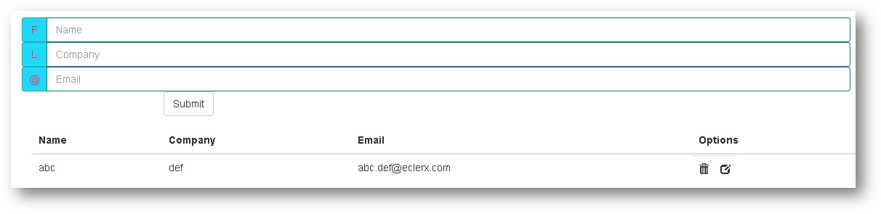

Q3: Display the data in tabular grid. (Data can be read from json <https://jsonplaceholder.typicode.com/todos> or some array)

Allow the user to make inline modification to data and reflect the changes in table accordingly.

Q4: Use json (<https://jsonplaceholder.typicode.com/comments>) to display user email address and body in the form of cards. Create a drop down of a to z alphabets. Whenever user select “a” in dropdown, only those cards should be shown whose domain name in email address starts with “a”.

